Dashboard Design
Team ID | MCA
Project Name | Smartphone Usage, Digital Addiction & Well-Being Analytics
Maximum Marks | 5 Marks
Dashboard design involves presenting important data through clear, interactive, and visually appealing visualizations. In this project, a Power BI dashboard has been developed to analyse smartphone usage, digital addiction, and user well-being. The dashboard contains data from 7,500 users and uses KPI cards, bar charts, pie charts, and interactive slicers to present the analysis.
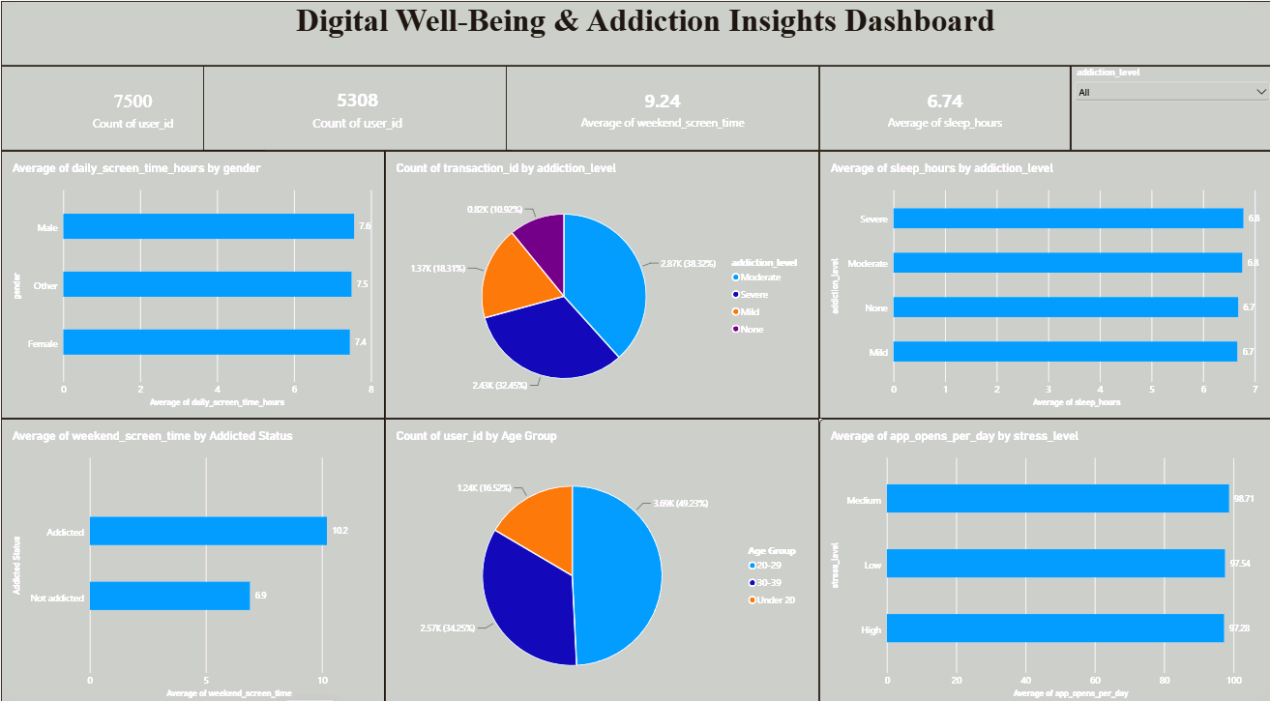
Activity 1: Interactive and Visually Appealing Dashboard
The dashboard has been designed using the following principles:
- Clear and Intuitive Layout: KPI cards are placed at the top, followed by charts for detailed analysis.
- Appropriate Visualizations: Bar charts and pie charts are used to compare addiction levels, age groups, gender, sleep, screen time, and stress.
- Colour and Theming: A consistent blue and neutral theme is used to maintain a clean and professional appearance.
- Interactive Filters: An Addiction Level slicer allows users to filter and explore the dashboard interactively.
- Drill-Down Analysis: Different categories such as gender, age group, addiction level, and stress level allow users to examine the data from different perspectives.
- Professional Presentation: Titles, labels, legends, and data values are formatted to make the dashboard easy to understand.
Major Outcomes from the Dashboard
- Total Users: The dashboard analyses 7,500 users with an average age of 26.57 years.
- Addicted Users: 5,308 users are identified as addicted, representing approximately 70.77% of the total users.
- Screen Time: Average daily screen time is 7.50 hours, while average weekend screen time increases to 9.24 hours.
- Addiction Levels: The users are categorized into Moderate, Severe, Mild, and None addiction levels. The Moderate category contains approximately 2.87K users.
- Age Group: The 20–29 age group represents approximately 49.23% of the users, making it the largest age category in the dashboard.
- Sleep and Well-Being: Average sleep duration is 6.74 hours, with sleep averages across addiction levels ranging from approximately 6.7 to 6.8 hours.
- Gender-Based Usage: Average daily screen time is approximately 7.6 hours for Male, 7.5 hours for Other, and 7.4 hours for Female users.
- Stress and App Usage: Average app opens per day are 98.71 for Medium stress, 97.54 for Low stress, and 97.28 for High stress users.
- Weekend Usage by Addiction: The dashboard shows approximately 10.2 hours of weekend screen time for addicted users compared with 6.9 hours for non-addicted users.

